Section A

- Choose the correct definition of a hydrocarbon.
Tick ( ) one box.
- A molecule that contains carbon and water atoms only | 
- A molecule that contains carbon and hydrogen atoms only
- A molecule that contains a mixture of carbon and hydrogen atoms

- Complete the chemical formula for propane.

C__H___

- Choose the substance that hydrocarbons react with during combustion.
Tick ( ) one box.
- Air
- Oxygen
- Carbon dioxide

- Complete the general equation for the complete combustion of alkanes:

Alkane + ________________ ____________ ___________ + _______________

- Describe what is needed for complete combustion of alkanes to take place.

__________________________________________________________________________________________
__________________________________________________________________________________________

Section B

- Methane is a common hydrocarbon that is used as a domestic fuel.

- Write a balanced symbol equation for the complete combustion of methane.

____________ + ____________ ____________ + ____________

- Explain why the incomplete combustion of methane may be dangerous.

__________________________________________________________________________________________
__________________________________________________________________________________________
__________________________________________________________________________________________

- Complete the reaction profile for the combustion of methane.
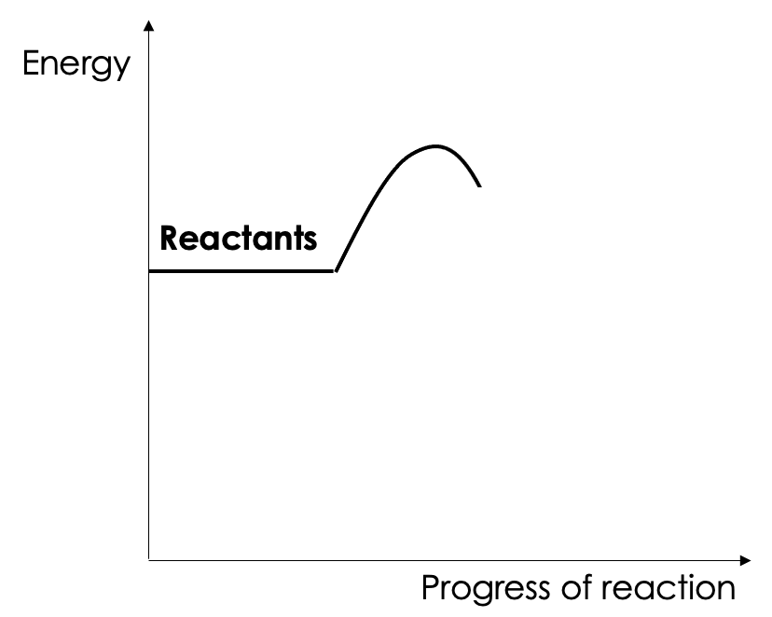

- Explain your answer to question c.

__________________________________________________________________________________________
__________________________________________________________________________________________
__________________________________________________________________________________________

- Petrol is used as a fuel in many cars. One of the compounds in petrol is octane (C₈H₁₈).

- Complete the word equation for the reaction of octane that takes place in a car engine:

Octane + ______________ _________________ + ___________________

- Cars should use sulfur-free petrol. Explain why.

__________________________________________________________________________________________
__________________________________________________________________________________________
__________________________________________________________________________________________

- Many scientists are concerned about one of the products of the complete combustion reaction of octane in car engines. Identify the product that is concerning scientists and explain why it is a concern.

__________________________________________________________________________________________
__________________________________________________________________________________________
__________________________________________________________________________________________
__________________________________________________________________________________________

The table below provides data on the composition of gases from the exhaust of a petrol engine.

Gas | Percentage
Nitrogen | 67
Carbon dioxide | 16
Carbon monoxide | 1.5
Oxygen | 0.5
Nitrogen oxides | 0.15
Sulfur dioxide | 0.02
Other gases

- Calculate the percentage of other gases present.

__________________________________________________________________________________________

- Name the compound that makes up most of the other gases.

__________________________________________________________________________________________

Section C

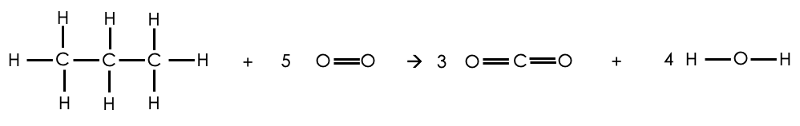
- Below shows the reaction between propane and oxygen. This reaction is exothermic as 2018 kJ/mol more energy is released when forming the bonds than is taken in to break the bonds in the reactants.

Bond | Bond Energy (kJ/mol)
C-H | 413
O=O | 498
C=O | 799
O-H | 464

- Use the information given to calculate the C-C bond energy.
- Calculate the mass of carbon dioxide that would be made when 100 g of propane burns in 600 g of oxygen.
Relative atomic masses:
Carbon = 12
Hydrogen = 1
Oxygen = 16

